**Assignment-3**

**Name:-** R Sujith

**Reg No:-** 21BCE7696

**Course:-** Data Analytics collaboration with ibm

Cognos

**Branch:-** VIT-AP(Amravati)



**Challenge: -**

Upload the dataset to MySQL and integrate with Tableau , delete the unnecessary columns, explore and visualize the dataset using Tableau.

**MySQL workbench: -**

**First, we create a database in schemas and upload table and connect to the tableau. So, I have dropped time in the table because it is no use for visualization and any operations. Therefore, we remove time from the table.**

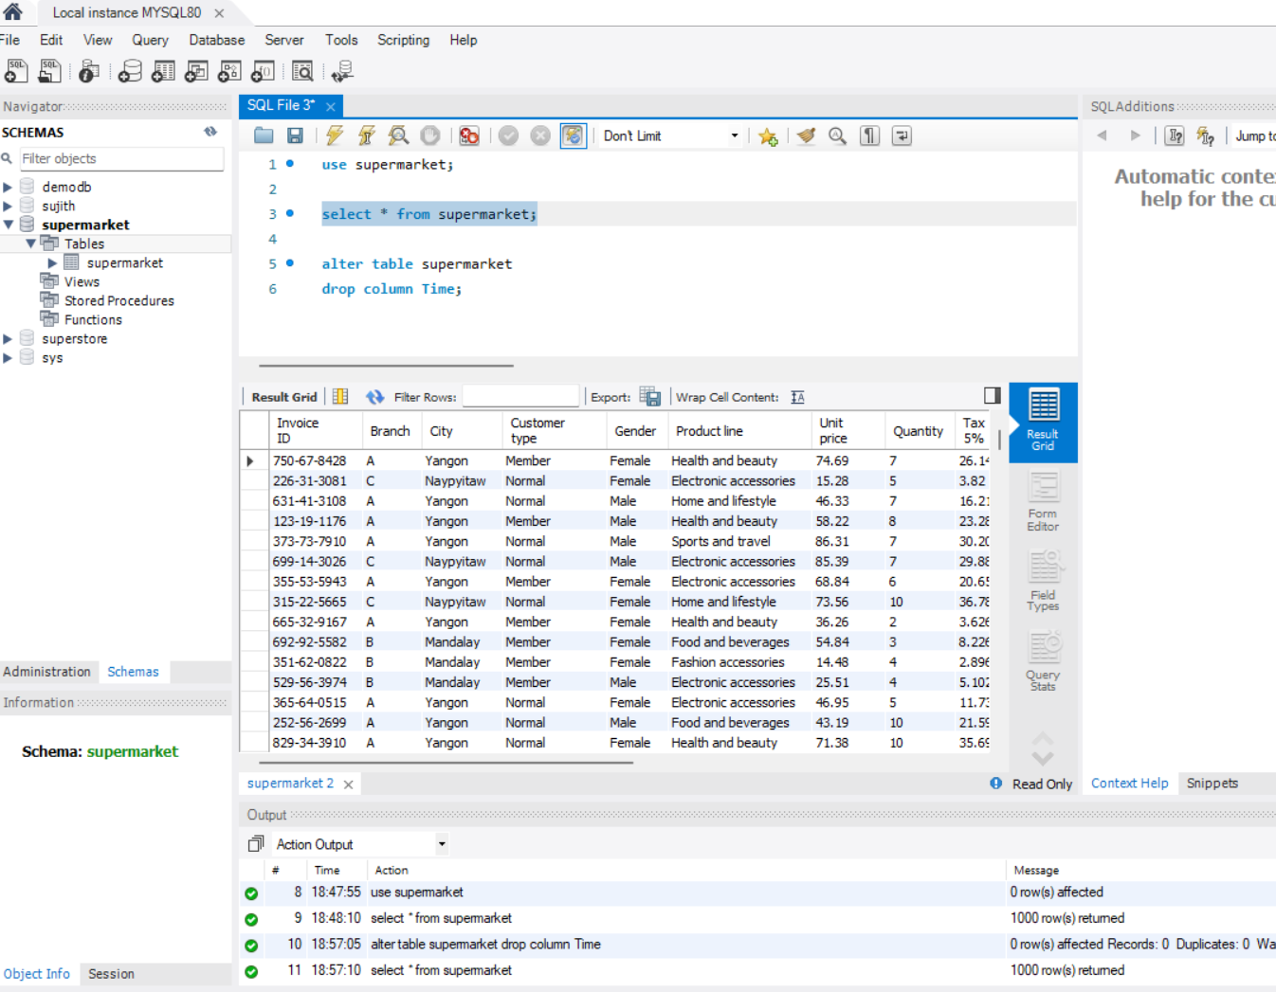

**Tableau Visualization: -**

**1)Bar Chart: -**

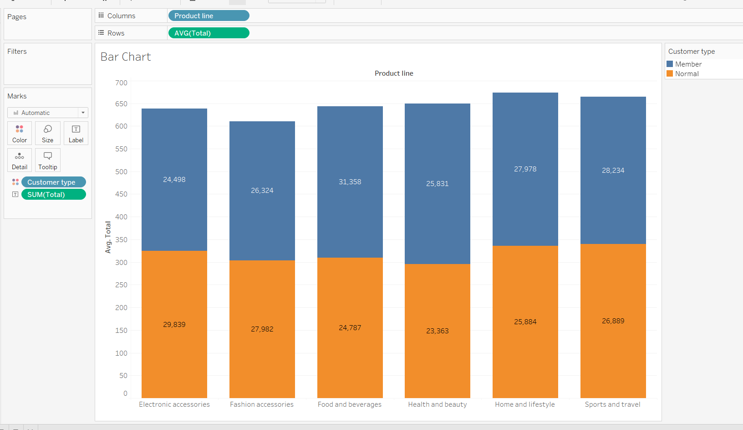

**2)Histogram: -**

**3)Pie Chart: -**

**4)Heat Map: -**

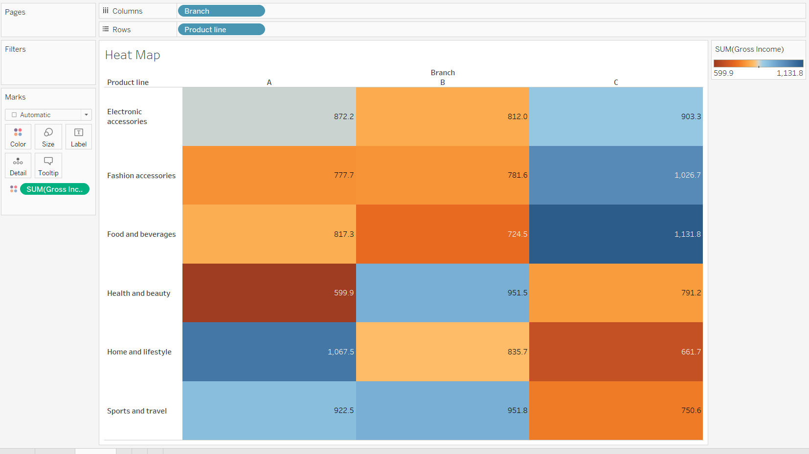

**5)Bubble Chart: -**

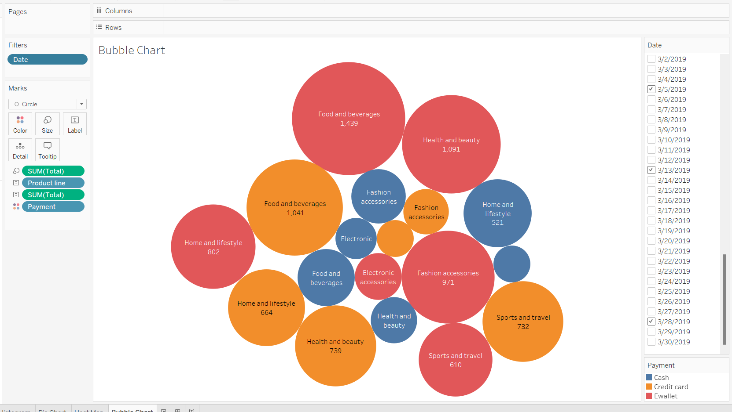

**6)Line Chart: -**

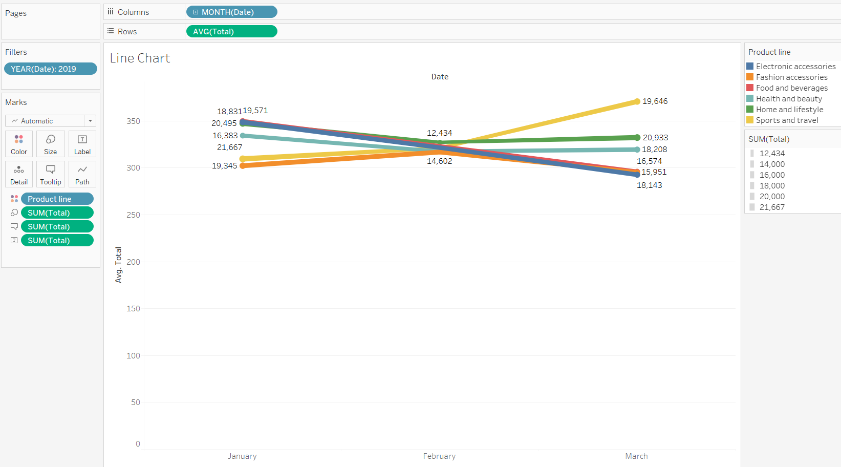

**7)Tree Map: -**

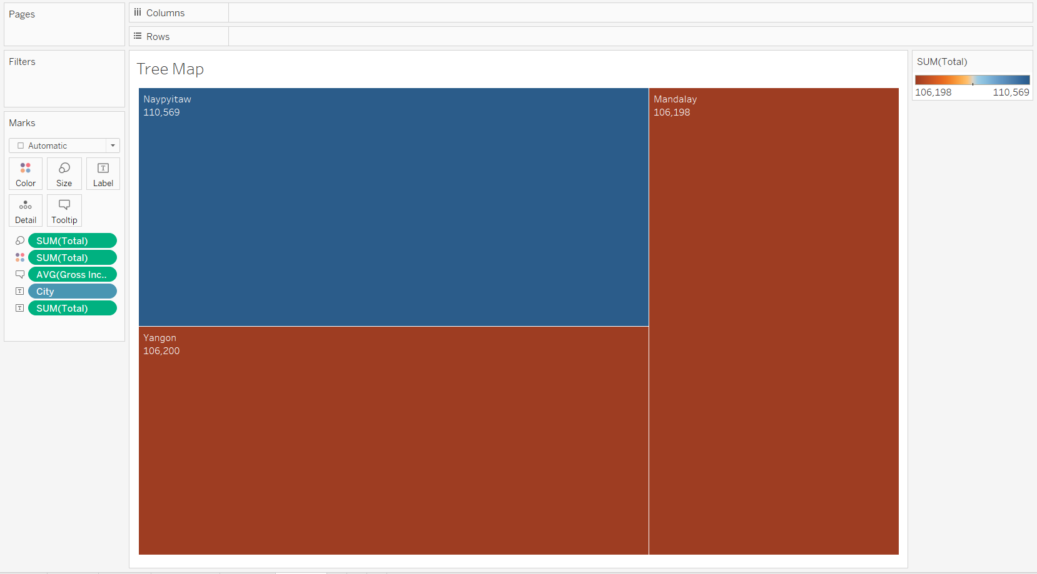

**8)Motion Chart: -**

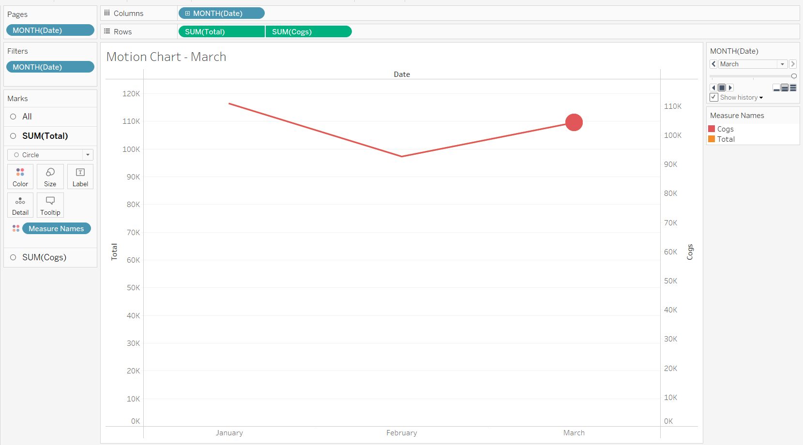

**9)Bullet Chart: -**

**10)Scatter Plot: -**

